**RESUME**

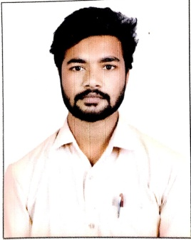

# MAIBOOBSAB NADAF

Email: nmaheboob726@gmail.com

Mobile no’: 7026736977

Address: ap: narasalagi tq:basavana bagewadi Vijayapur-586203, Karnataka

##### OBJECTIVE

* Looking for an internship opportunity
* Obtain a responsible position in an organization with best capabilities, skills and knowledge

##### ACADEMIC QUALIFICATION

* 10th at mdsp composit pu college narasalagi
  + Karnataka SSLC board-62%
* Diploma in Computer science (3rd year) at BLDEA’s SSM Polytechnic
  + 1st Year-64.22%
  + 2nd Year-58.0%

##### PROFESSIONAL SKILL

* Artificial Intelligence and Machine Learning
* DBMS with basic
* Data structure with Python

**PROJECTS THAT WORKED ON**

• MPG dataset(ML)

• House price prediction(ML)

• Parkinson disease diagnosis(ML)

• Brest cancer diagnosis(ML)

• Titanic survival prediction(ML)

• Minist digit dataset(DL)

• Fashion minist dataset(DL)

**WORK EXPERIENCE**

• Fresher

**PERSONAL DETAILS**

• Father: allisab nadaf

• DOB: jul 18 1999

• Gender: Male

• Nationality: Indian

• Languages known: English, Hindi, Kannada

Place: vijayapura

Date : 16th JAN 2023